**Database Management lab Mini Project**

Overview

1. Download and Installation of Wamp Server.
2. Database table management with PhpMyAdmin.
3. Back-end scripting using PHP/MySQL.
4. Download and Installation of Wamp Server.

Steps.

**Step 1 - Check, Download and Install VC++ Redistributables for Windows.**

* Open Control Panel and navigate to ‘Uninstall a Program’
* Check if Microsoft Visual C++ Redistrutables from 2005 to 2015 are installed. If yes, skip the next steps and move to **Step 2 - Download and Install Wamp Server.**

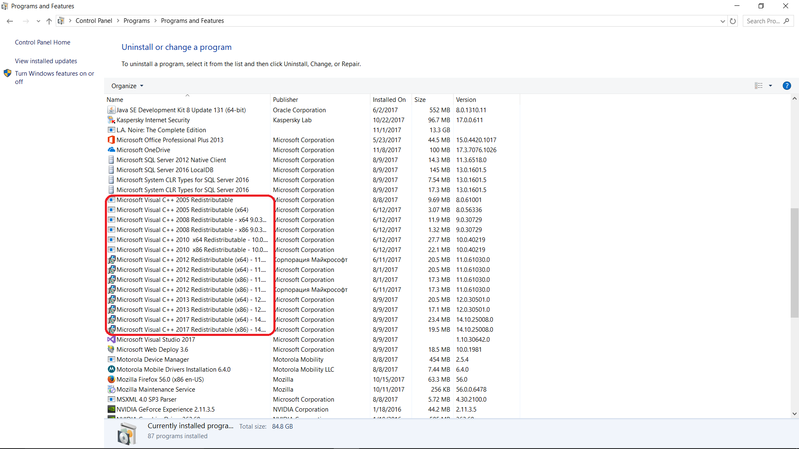

* Go to <https://support.microsoft.com/en-in/help/2977003/the-latest-supported-visual-c-downloads> and download the required VC++ versions.

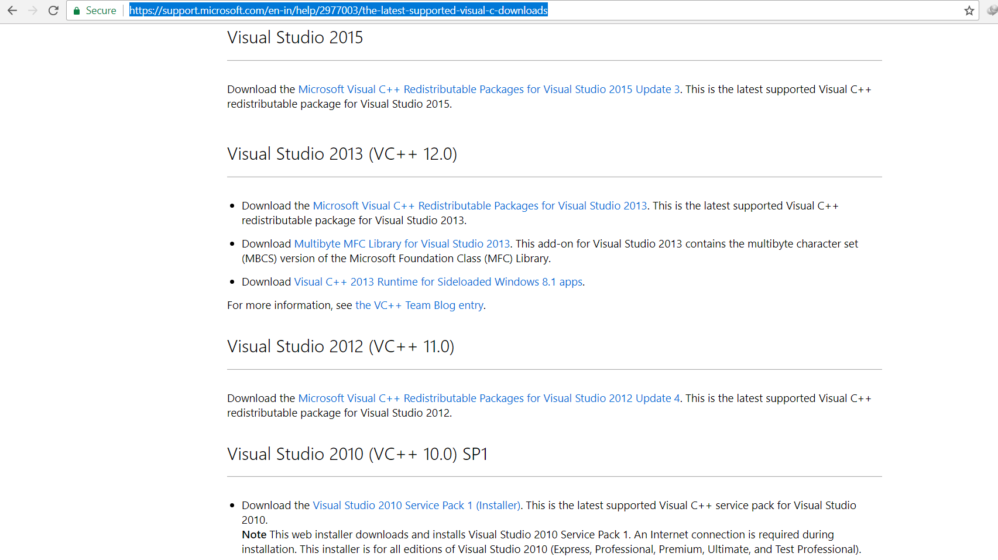

* Open the exe file.

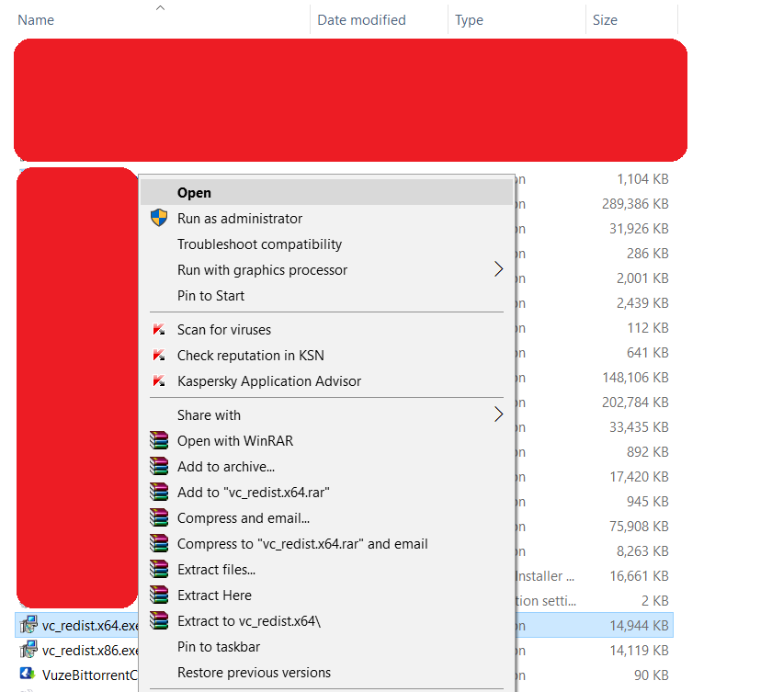

* Follow the steps to install the package.
* 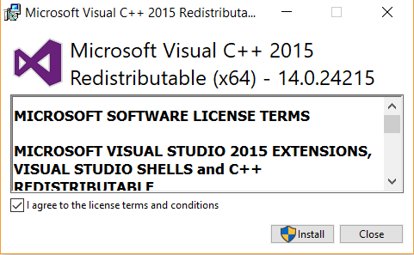
* For 64bit operating systems, you must install both the x64 and x86 versions.
* Perform the installation for all the versions of VC++.

**Step 2 - Download and Install Wamp Server.**

* Navigate to <http://www.wampserver.com/en/> on your browser.
* 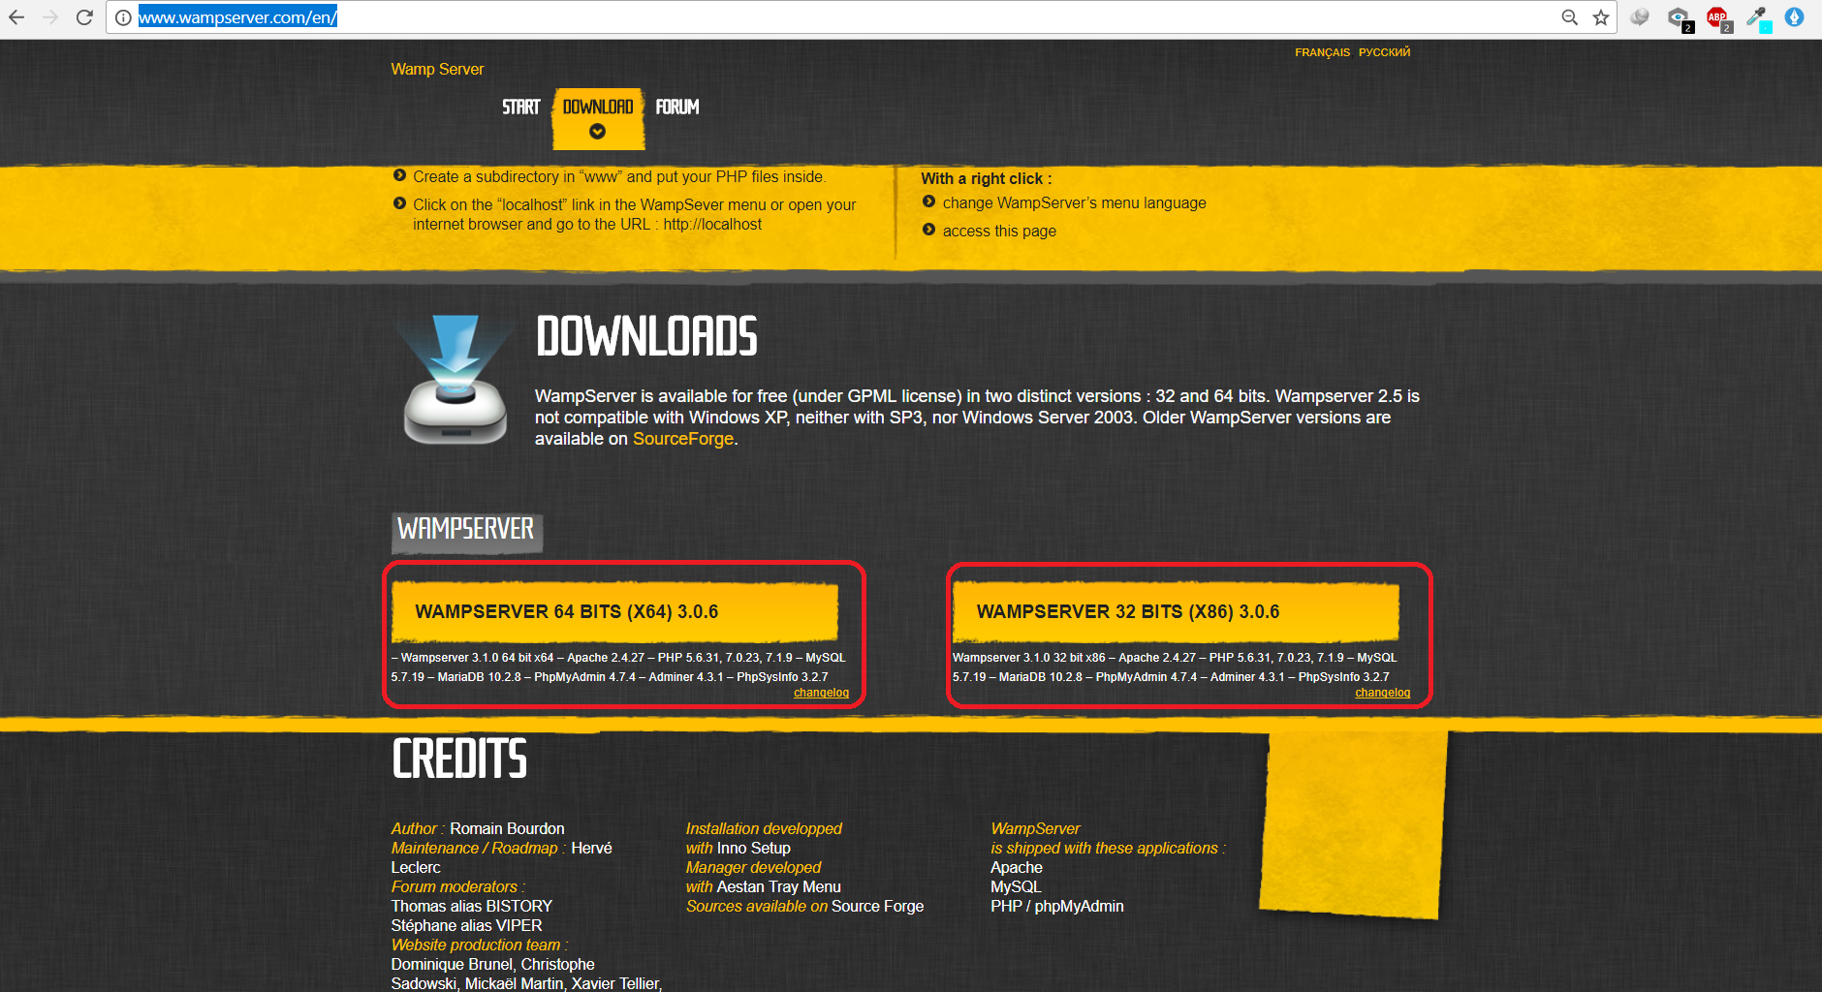
* Depending on your Operating System, Click on either 64bit or 32bit version.
* Download the .exe file
* Right Click and Run As Administrator.
* 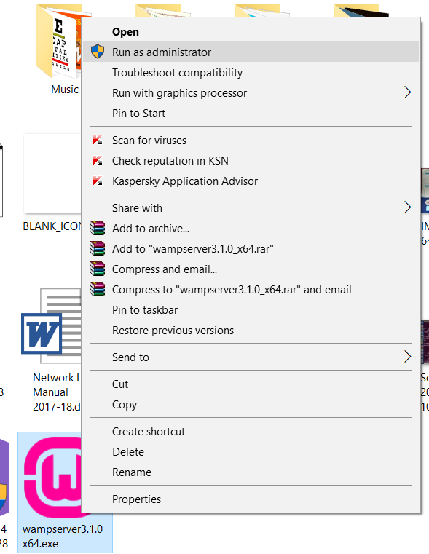
* Click on **I Agree** and click next.
* 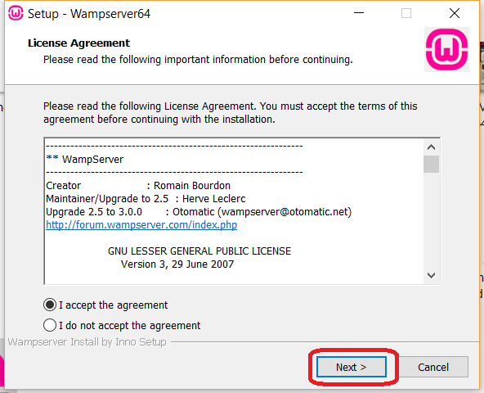
* Click next and ensure that Installation Directory is set to “C:\Wamp64”. Click next to proceed.
* 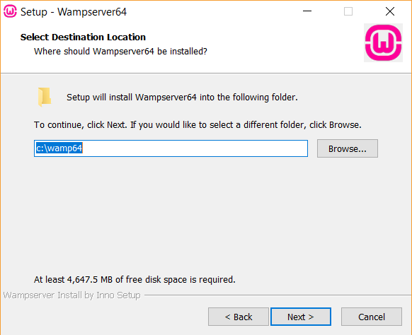
* The installation should begin. Click on **Finish**when done.

**Step 3 - Check Localhost and Login to PhpMyAdmin.**

* Open Start from Taskbar and type “WampServer64”. Click on it to start Wamp Server.
* 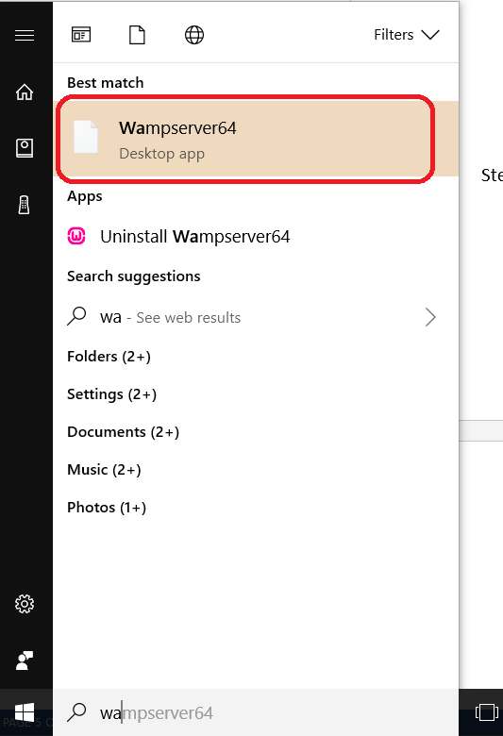
* If all the steps have been followed correctly, the Server should start and it will be visible in your taskbar. The Wamp icon will be displayed in Green which ensures that all services are running perfectly.
* 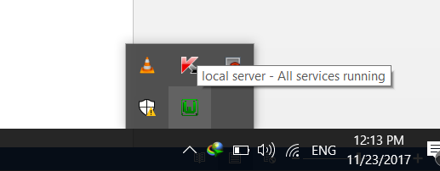
* Open Browser and type “Localhost” in the URL bar. You will get this page.
* 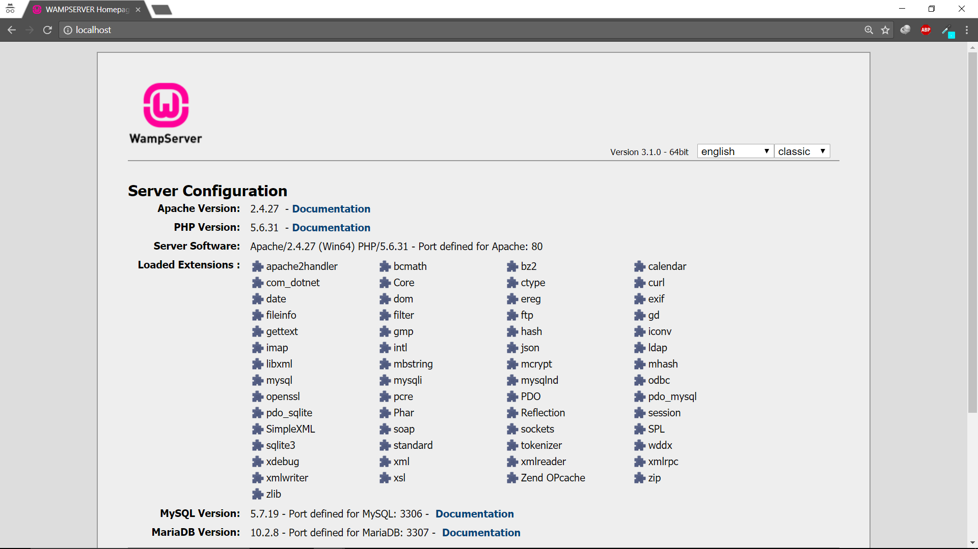
* Type “localhost/phpmyadmin” in the Url and press Enter. You will be taken to the login page.
* 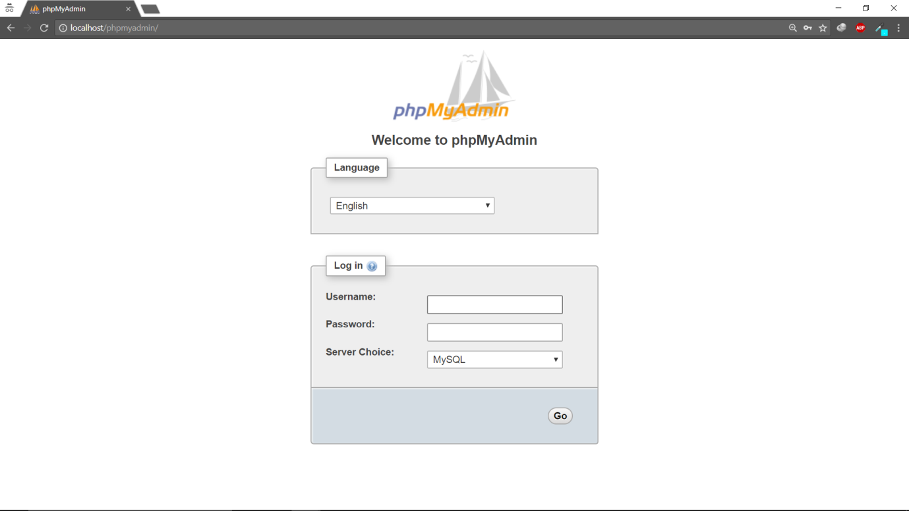
* Type in root as username and leave the password field empty. Press Go.
* On successful login, you will be taken to the phpmyadmin dashboard.
* 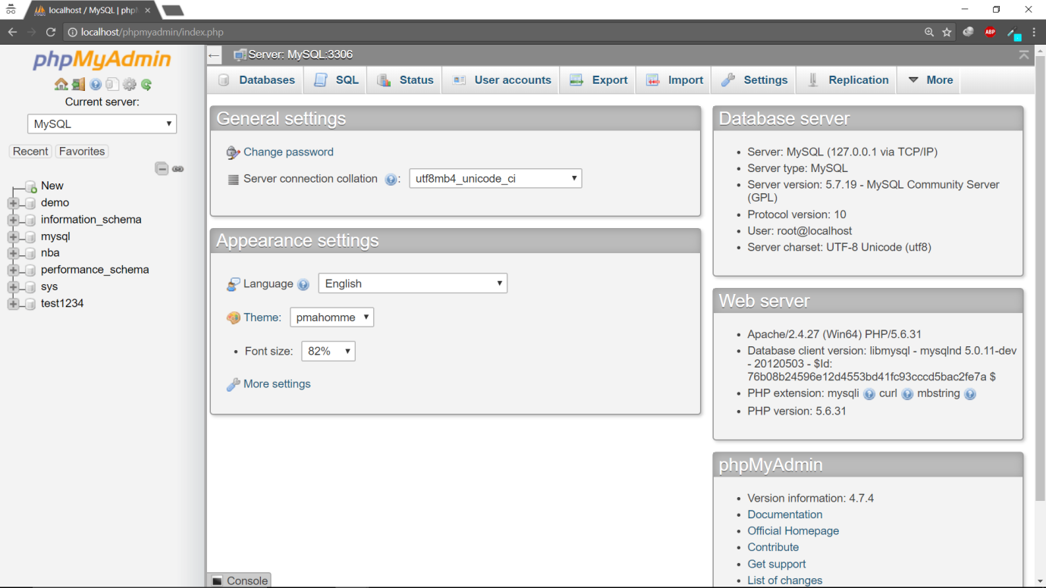

1. Database table management with PhpMyAdmin

Steps.

1. **Create tables and Insert values into them.**

* Before creating a table, we must create a database. Click on the New button on the dashboard.
* 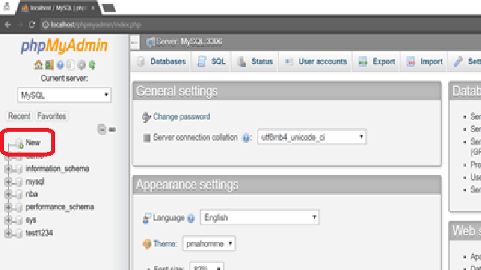
* Type in the name of your database and click on Create.
* 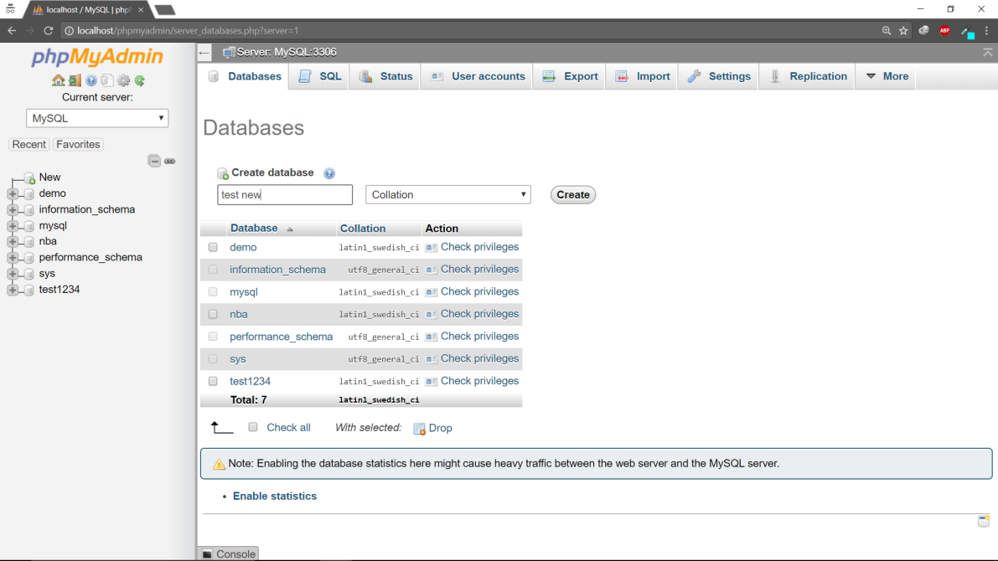
* It will create a database and take you to create a table page.
* Create a table with any number of columns. Press save.
* 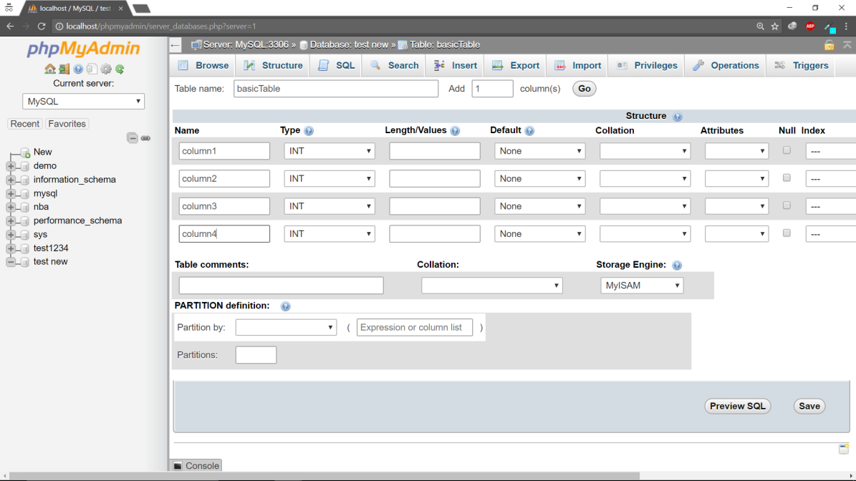
* Once the table is created, you can view the description.
* 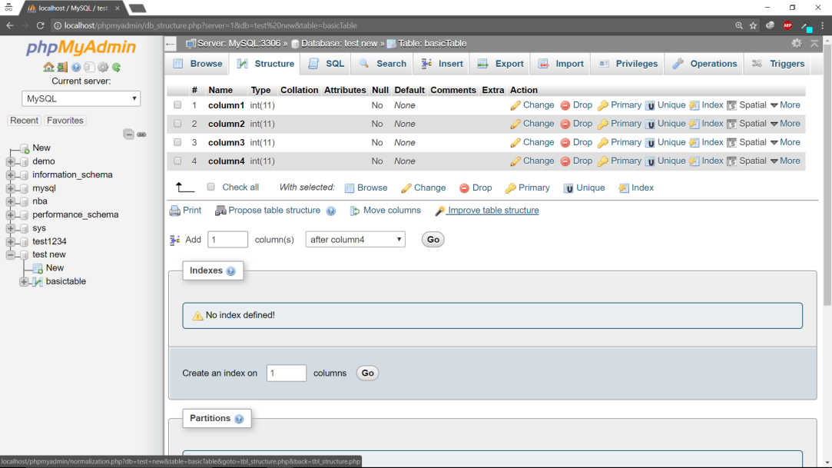
* Now we will insert values to the table. Click on the Insert tab on the top of the dashboard.
* 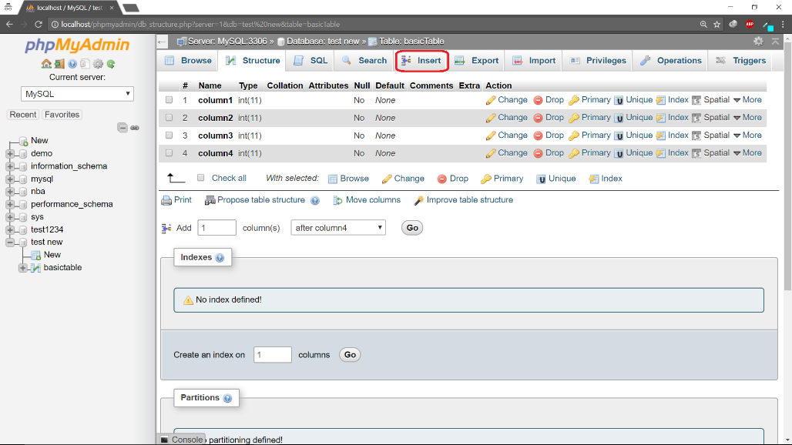
* Enter the column values and press go.
* 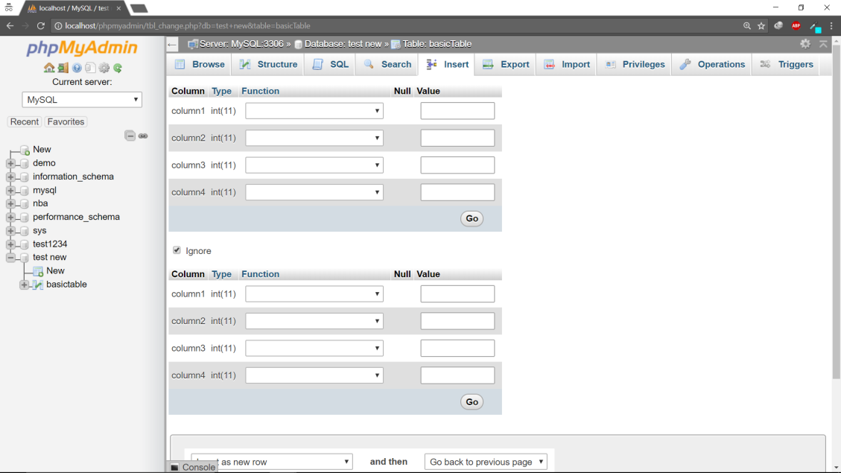

1. **Create Primary and Foreign key constraints.**

* Creating of Primary key constraints. Click on Structure of the table you want to use. Add primary constraint to the column of your choice.
* 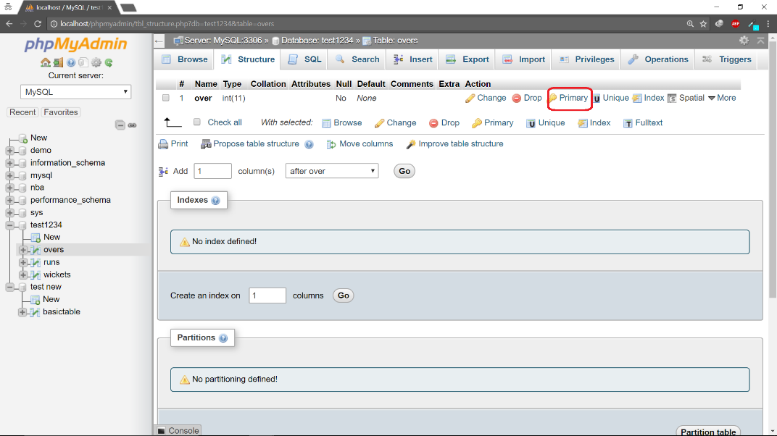
* If primary key was added successfully, it will be visible under index.
* 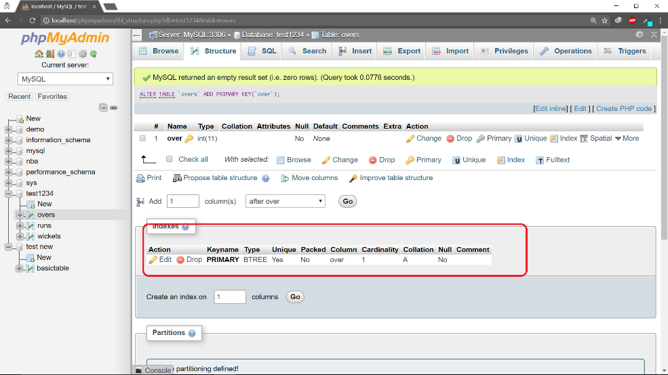

1. **Create Triggers and Stored Procedures.**

* Navigate to the table you want to add the trigger to.
* 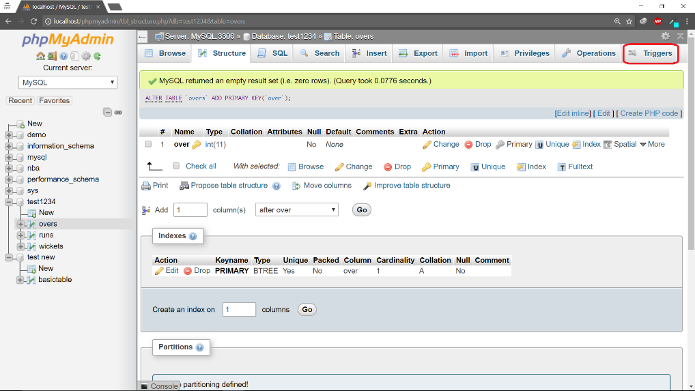
* Click on add trigger. Now you can add a trigger.
* 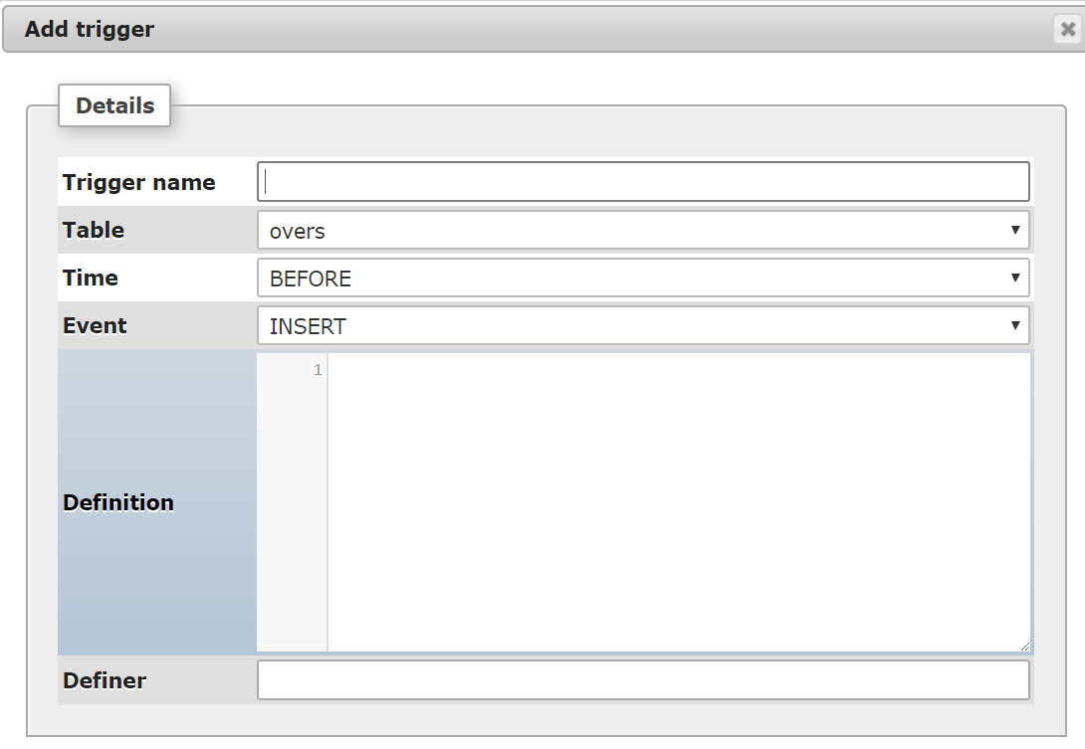
* Adding a Stored Procedure - Click on the database. Now click on Routines on the dashboard.
* 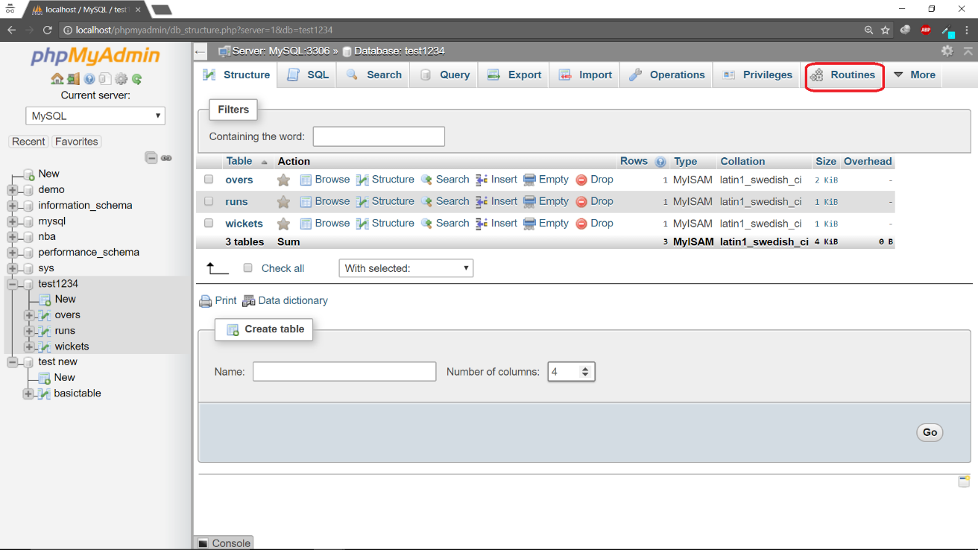
* Click on add Routine and add the stored Procedure.
* 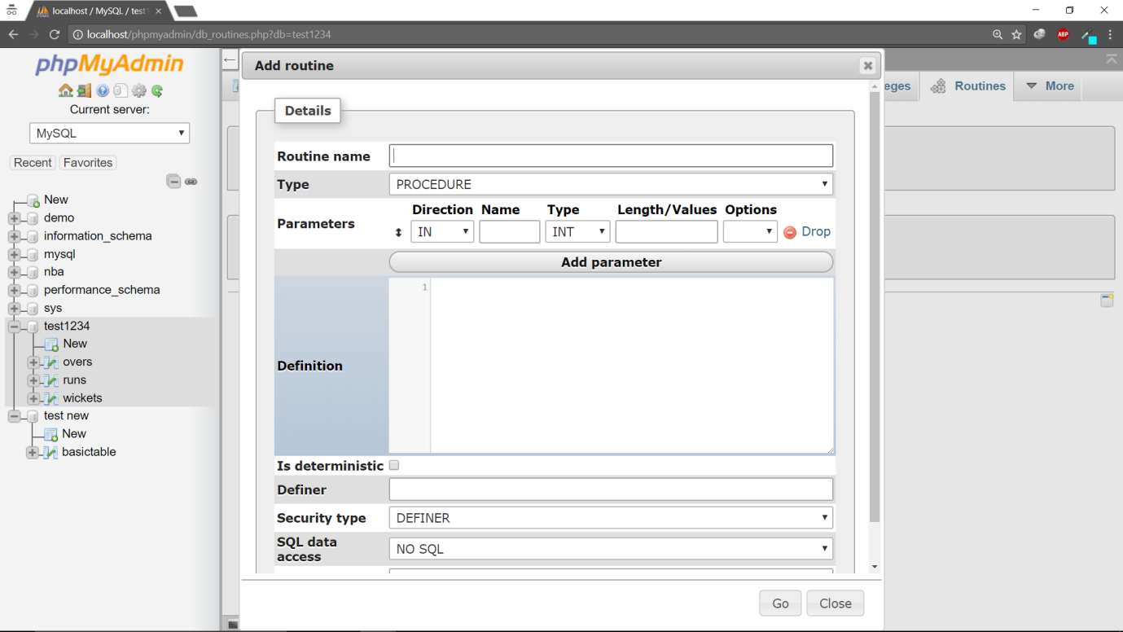

1. Back-end scripting using PHP/MySQL.

Steps.

1. **Write PHP code to connect to database, execute a query and display data.**

* Now that we have data in our database. We must access that data from our code.
* Firstly, we must make a connection to the database. Open your text editor and type in the following code.
* 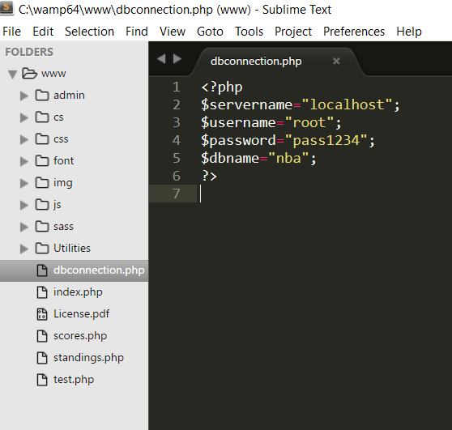
* The variables servername, username, password, dbname hold your server, phpmyadmin username/password and database name respectively. We will call this php file everytime we make a connection to our local database.
* The below code will make a connection to the database using the mysqli_connect() function.
* 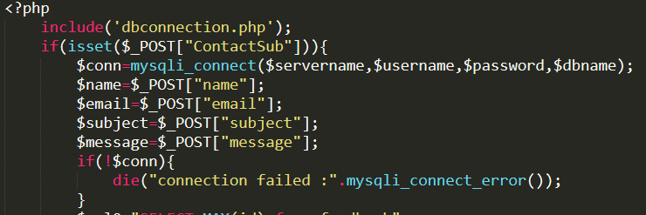
* A query is executed as follows.
* 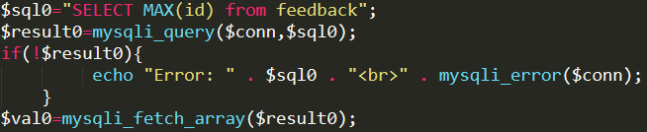
* $val0 stores a 2d array containing the table returned by the query.
* Insert, Update and Delete operations can be performed in a similar fashion.

1. **Link PHP code with front-end.**

* The same php code can be integrated to your html code.
* 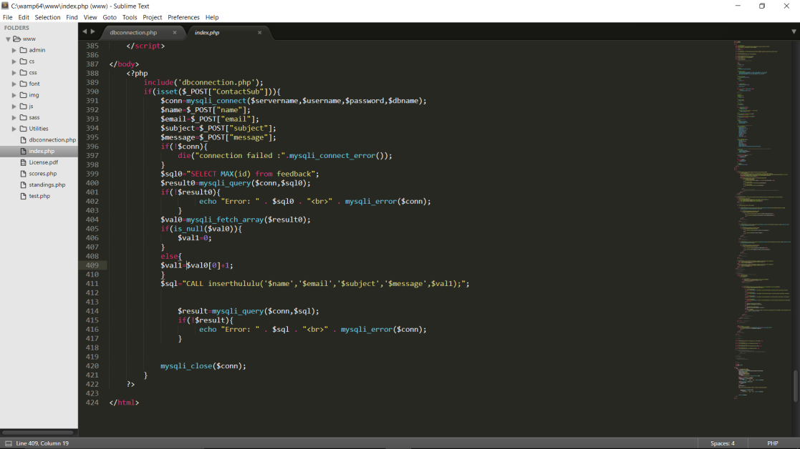
* The php can be inserted anywhere in the html. The data values can be echoed wherever necessary.
* 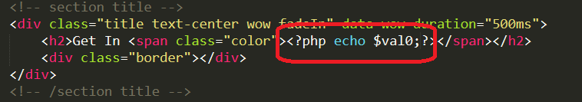
* Now that all the files are saved, we must place them in the following directory, so that it can be accessed by localhost.
* 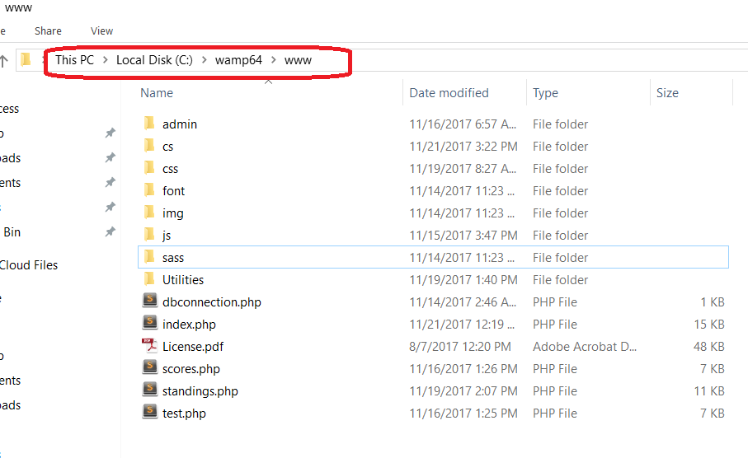
* The website can now be accessed by typing localhost in the browser.